
MINUTES OF COMMITTEE MEETING

Location of meeting : Uphall Golf Club | Minutes Prepared by : Steve Grady
Date : Monday 11th March 2019 | Reference Number : 01/19

Present | Yes/No
A Stevenson (Captain & Linlithgowshire Rep) | Yes
M Brown (Vice Captain) | Yes
B Mackintosh (Treasurer) | Yes
S Grady (Secretary) | Yes
G Stevenson (Match Secretary) | Yes
G Law | Yes
D Watson (House Convenor) | Yes
S Watkins (Ladies Captain) | Yes
S McKinnon | Yes
R Middleton | Yes

Distribution - All Council Members, Golf Course and Membership / Sponsorship Manager, Administrator, Gents and Ladies Locker rooms and Website.

 |  | Action
1.0 | Apologies for absence
1.1 | None | Noting
2.0 | Previous Minutes
2.1 | The minutes were accepted as a true record of the previous meeting.  Proposed by : G Law  Seconded by : S McKinnon | Noting
3.0 | Matters Arising and Action List
5.1 | Scorecards – a reminder is to be issued to all members on the importance of submitting their scorecard at the end of each competition. | GS
7.1 | A revised Snagging list has been produced and all items require to be investigated per list in the body of these minutes.  After 3 months without any water ingress in the back bar following the roof repair, we proceeded with the works to improve lighting etc. Unfortunately, there has been a further leak and additional investigative work is now needed to try and ascertain once and for all, the root cause of the issue. | DW/  SMc
15.1 | 125th anniversary of the golf club in 2020 – two strategy meetings have been held with another scheduled for 8th April – looking to progress a couple of competitions and a dinner with consideration being given to hiring a marquee. | GL/MB
15.1 | The Match Secretary is to issue a guidance note providing further clarity on the new rules | GS

4.0 | Treasurer’s Report
4.1 |  | Noting
  Uphall Golf Club Figures Month 4 |  | As at 28th February 2019
  Bank
  Current Account |  | £1,129.30
  Subs Account |  | £40,000.00
  Net Position |  | £41,129.30
  Due to Suppliers |  | £13,357.27
  Bar Cumulative |  | YTD
  Sales |  | £42,599.17
  Purchases | 17,548.86
  Opening Stock | 6,472.00
  Closing stock | 6,370.89 | £17,649.97
   |  | £24,949.20
  Gross Margin |  | 58.57%
  Wages |  | -£12,408.15
  Outturn Profit YTD |  | £12,541.05
  Net Margin |  | 29.44%
4.2 | Financial Performance – Other  YTD  Green Fees £4,542.16 | Noting
4.3 | The Bank account is running well with no use of the overdraft facility. The Bank account comparison figures show that the Bank account is improved on prior year.  Circa £3k of the funds relate to the Junior Foundation.  Suppliers figure includes circa £7k due to be paid to Scottish Golf (end March)  All suppliers are up to date with circa £11k being attributed to our Brewers.  Green fees ahead of previous year, principally due to better weather in the early part of the year. | BM
5.0 | Match Secretary’s Report
5.1 | Winter Medals  - Winter Medals were held on Sat 16th Feb and Sun 3rd March. Stephen McCarron (13) won both with 41 Stableford points. Consideration was given to a General Play reduction but given both scores were in non-qualifying competitions then decision made to not to take any action at this point.  Winter Opens  - 4th Winter Open was held on Sat 9th Feb. The winner was Peter Wilson with 40 Stableford points with all 7 prize-winners being home players.  - Yesterdays’ Winter Open was cancelled due to adverse weather. Consideration to be given on whether we want to try to reschedule this or not.  Matchplays and Captain v Vice Captain game  - E-mail sent out last week with details of both asking for entries.  Fixture list  - I believe the final version is now with the printers and so should be available in the next couple of weeks. As has been done in previous years I will send out a Word document via e-mail this week with a copy to all members.  Competition rules/guidelines  - Ready golf – e-mail to be sent to members with guidelines the week before the playing season commences.  - Return of cards in box and/or computer. E-mail to be sent to members with guidelines the week before the playing season commences. I propose that if someone does not return their card and/or enter it into the computer on 2 occasions throughout the season they will automatically be banned from the next 2 relevant competitions (whether that be a midweek or weekend competition).  Health & Safety visit  - The visit scheduled for Friday 15th March at 4.30 has had to be cancelled due to there being no available access to the pro shop or the greenkeepers shed on that date/time. Peninsula have stressed that a visit from them is significantly overdue and that we should look to arrange imminently.  A discussion then took place in respect of:-  - Handicap changes for Winter Medal results – whilst the committee felt merit to introduce this, given the stage in the season it was felt best to leave this for consideration for any future Winter Medal programme.  - Non-input of scorecards for competitions – this is becoming more prevalent and is causing increased work as reconciliation work is extremely resource hungry – it was decided that a general reminder would be issued to all members before we introduce a more stringent sanction. | Noting
6.0 | Greens Convenor’s Report
6.1 | Work Completed  - 8mm solid tining to all greens using verti drain  - Two way scarification of all greens and clear debris  - Hollow core all greens 3”x2” centres. 4th green was done on two occasions.  - Apply liquid formulations, granular charcoal and lime  - Overseed scarred areas on greens.  - Apply 20 tonne of FS9 sand to greens and brush in  - Apply further 10 tonne FS9 sand and brush in.  - Verti drain fairways at 4,5,12 and 14  - Verti drain tees at 4,5,9 and 12  - Apply fungicide to all greens for Fusarium disease control  - Fairways and tees cut  - Continue to control mole population on course  - Brick shed has been cleared of debris and unused items of equipment    Future Works:  - Commence spring renovation works to Tees week beginning 11th March  - Continue verti draining outstanding tees and fairways  - Apply soil penetrant to all greens  - Mowing of fairways, tees and approaches will continue.  - Arrange contractor to remove large tree limb at 5th tee  - Complete winter programme  Winter Programme Update  - Path from 3rd tee to 15th tee 100% complete  - Re contour rear of 14th green 100% complete  - 1st tee shaping, levelling, installing drainage, logs, steps and laying turf 100% complete  - Bunker construction at 4th hole – 90% complete  Bunker renovation at 7th hole – 100% complete  Bunker construction at 6th hole – 80% complete  Bunker construction at 3rd hole – 0% complete  We anticipate that this year’s winter programme will be completed within the next two weeks. After completion we plan to visit a significant number of the remaining course bunkers to make improvements in bunker edging and consistency of sand depth.  Course Update  Greens – a calculated risk was taken to bring forward the spring renovation works to greens by three weeks. This decision was taken recognising a positive medium range forecast that should put us in a stronger position in relation to green playability for commencement of main playing season.  The bunker renovation works had been halted as we progressed with works to greens. However works have recommenced this week (4.3.19). Following the 50mm rain that we received over past week it became evident that the drainage that we had installed at the bunkers on 4 were not performing as well as had been envisaged. To increase drainage capacity we have extended width of drain tracks. We are confident that this will deliver a satisfactory outcome.  Whilst investigating drainage outlets for bunkers at 4, we discovered an old tile drain that exits on the boundary of our course adjacent to the forward 5th tee. This was cleared and water immediately flowed from it. This will assist with drainage at bunkers at 4 as well as 4th green.  Verti draining to tees and fairways will continue this month. Spring renovation works to tees will commence week beginning 11th March.  Course General:  Still relatively dry given the 50mm rain that has fell over past week. Positive comments from members on new bunker construction works.  A new hole cutter has been purchased for use at start of new season. This will deliver sharper and cleaner holes. New hole cups and flags have also been ordered.  Volunteer Thanks:  - Graham Bow, for supplying excavator machinery to assist with grading of 1st tee.  - David Meldrum, for his continued work on the course with dead tree removal and continued refurbishment of tee markers.  - Alan Carlyn for clearing significant debris at wall at 6th hole. He also found 211 golf balls and for assisting with sand application to greens.  - Phil Foster – for constructing and erecting bird boxes that have been placed on trees at right side of 4th fairway facing NE.  Health & Safety: No reportable incidents  Machinery Update  Winter servicing and repairs to machinery have commenced. The Eclipse tees mower and rough cut gang mowers have been returned to us.  It has been identified that the fairway mower cutting cylinders are not able to be sharpened due to excessive wear. A new set of cylinders and associated parts have been ordered.  The Eclipse greens mower that we are renting for the year will be delivered to us late March.  An annual maintenance contract has been signed for our irrigation system.  Continuous Development  I attended a BIGGA conference in Perth on 5th March. (Copy of programme circulated). Key learning and information points:  - Changes to legislation in relation to fungicide use for control of turf diseases  - Course design and techniques by Jimmy Kidd of DMK Golf Design  - Discussion panel led by Director of Greens at St Andrews Links  - Course budgeting by Club Manager at Kilmarnock Barassie  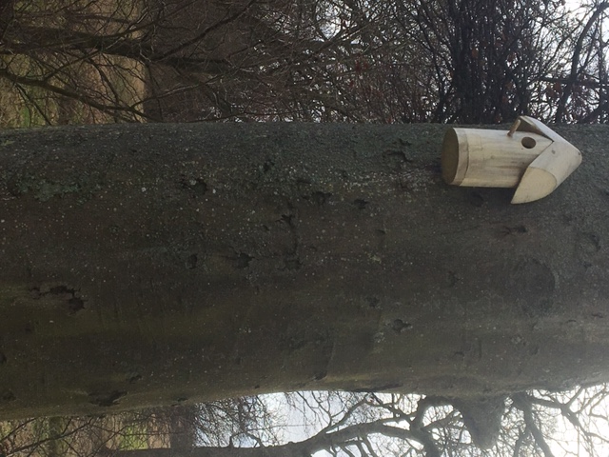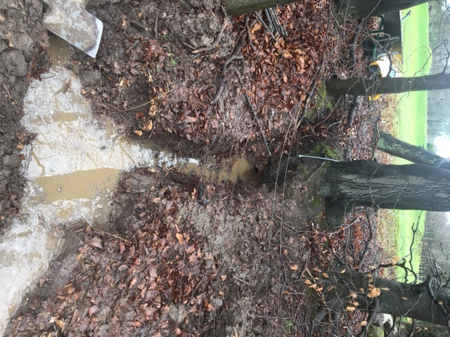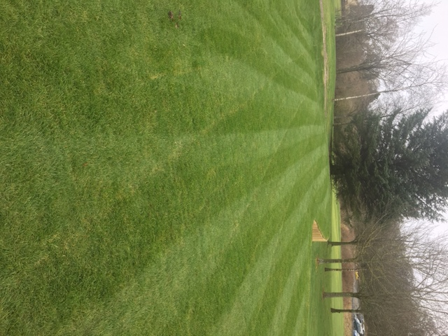  Drainage outlet to rear of 4th hole  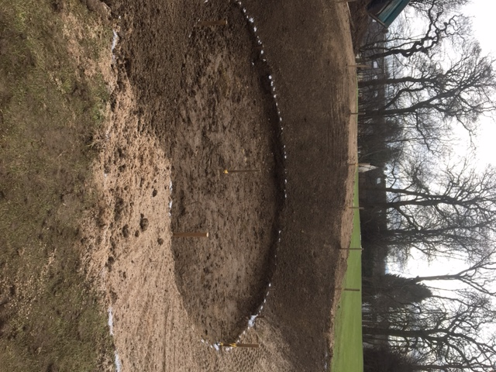  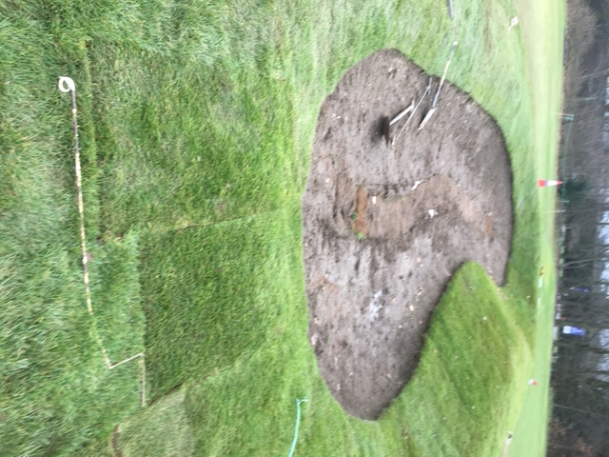  Jim Saunders  Head Greenkeeper  9th March 2019 | Noting

7.0 | House Convenor’s Report
7.1 | Up to date snagging list produced, and to be progressed by the House Convenor:-  - Members bar – Outside Door emergency light out. 1 light out. Door closure needs tightening  - Ladies Locker Room – Emergency light out. 1 light out  - Ladies Toilet – roof leak repaired to be checked  - Gents Toilet – roof leak repaired to be checked  - Outside – Archway 1 light out, balcony 3 lights out  - Hallway – 1 new light fitting required  - Staircase – reinstate photos  - Office – key cabinet lock broken  - Kitchen – new mixer tap and BT telephone cable box requires a new lid  I addition to the above the Septic tank system requires replacing which will incur substantial capital expenditure – quotes for this work are in the process of being obtained. |  |  |  | DW/SMc
8.0 | Junior Convenor’s Report
8.1 | The development programme during February went well. |  |  |  | Noting
9.0 | Senior Convenor’s Report
9.1 | No report submitted. |  |  |  | Noting
10.0 | Ladies Convenor’s Report
10.1 | Annual “litter pick” to take place and an email will be issued seeking assistance. |  |  |  | Noting
11.0 | Membership Report (Golf Course and Membership / Sponsorship Manager)
11.1 | Over the past month there has been 2 Senior, 3 Full, 5 PAYG and 1 Intermediate member resignations. New members this month consist of 2 Full, 4 PAYG |  |  |  | Noting
12.0 | Social, Bar & Kitchen Report
12.1 | Function business continues to be on the increase, in particular Wedding and Funeral business. |  |  |  | GL
13.0 | Sponsorship Convenor’s Report
13.1 | Renewal list complied re the tee Boxes and the Board at the roadside near the 3rd hole is to be used on a trial basis. |  |  |  | noting
14.0 | Secretary’s Report
14.1 | Nothing further to report. |  |  |  | noting
15.0 | AOCB
15.1 | A discussion took place on the merits or otherwise on holding a “new rules” evening in the club – it was decided that the best way forward would be to issue a guidance note providing further clarity on the new rules |  |  |  | GS
16.0 | Date of Next meeting
16.1 | The next meeting will be on Tuesday 9th April 2019 @ 6pm |  |  |  | noting
Council Meeting Attendance |  | Actual | Possible | %
A Stevenson |  | 01 | 01 | 100%
M Brown |  | 01 | 01 | 100%
B Mackintosh |  | 01 | 01 | 100%
S Grady |  | 01 | 01 | 100%
G Stevenson |  | 01 | 01 | 100%
D Watson |  | 01 | 01 | 100%
G Law |  | 01 | 01 | 100%
S Watkins |  | 01 | 01 | 100%
S McKinnon |  | 01 | 01 | 100%
R Middleton |  | 01 | 01 | 100%

